**General Directions:**

* This will be an independent page from 4IR, so menu and footer will look different
* We are keeping just one background color for the whole body of the website and just changing in in the footer
* We are forcing some colors in titles and subtitles
* Buttons should be more rounded
* We are keeping the color in the  <p> tag
* All book a Demo and Learn More buttons should open a Calendly popup

<!-- Calendly link widget begin -->

<link href="https://assets.calendly.com/assets/external/widget.css" rel="stylesheet">

<script src="https://assets.calendly.com/assets/external/widget.js" type="text/javascript" async></script>

<a href="" onclick="Calendly.initPopupWidget({url: 'https://calendly.com/bkrevoy/60-minute-meeting-for-4ir-consulting'});return false;">Book a Demo</a>

<!-- Calendly link widget end -->

Colors

* **Purple:** #8800ff
* **Yellow:** #ffce00
* **Dark Blue:** #0a131d

**Sections**

This is a landing page and the information in the menu should redirect to the internal sections



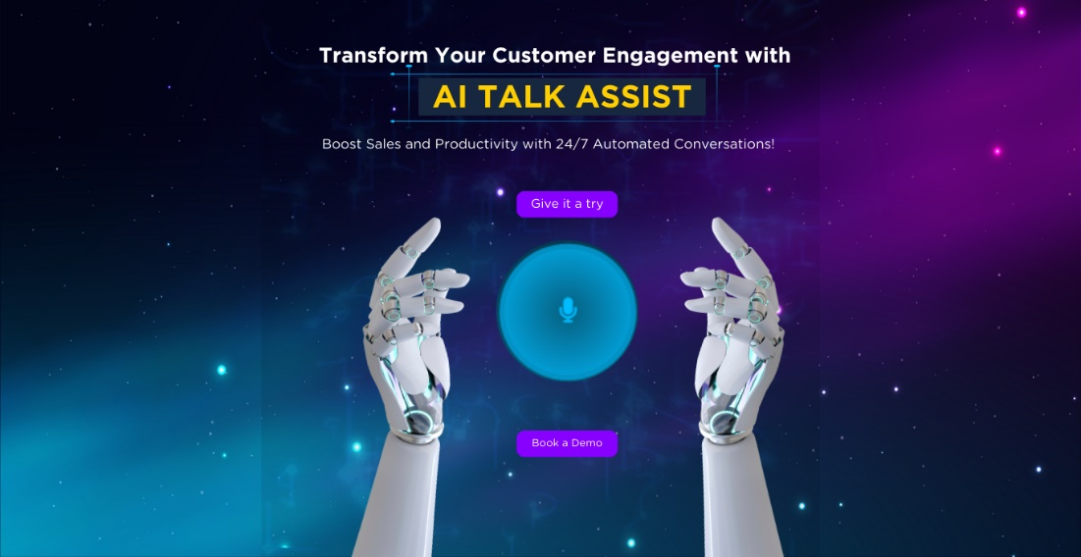

In this section we are using the boxes we have in the Services page with the following adjustments:

* Remove the default shadow and leave it just when we hover on an item
* Add transform: scale(0.98); in the .boxs_container .box:hover {
* increase the width of each box to 430px – 450px.
* Images as just for reference, I’ll work on the actual images and send them to you ASAP

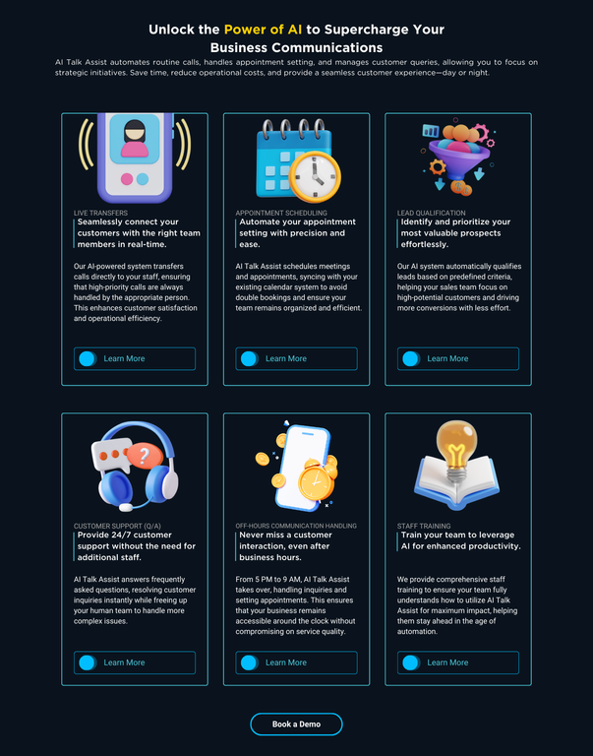

I copy this format from a website, here is the link <https://munainextjs.vercel.app/#>

I included the pictures of these 3 clients in the folder

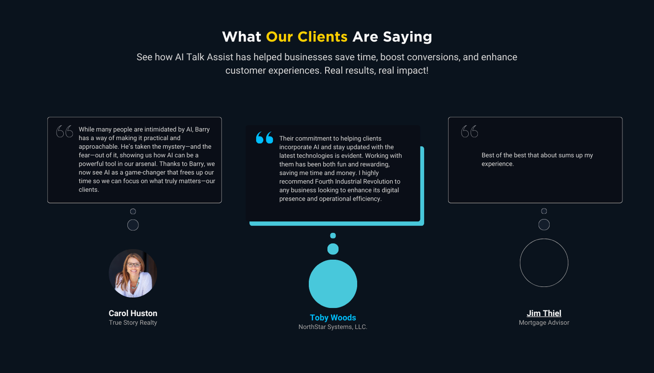

**See below all the questions with their respective answers:**

1. How does AI Talk Assist handle customer interactions without feeling impersonal?  
AI Talk Assist mimics natural human conversations, ensuring that customer interactions feel warm and personalized, enhancing user experience.  
2. Is AI Talk Assist difficult to set up?  
No, it’s simple to integrate into your existing systems, with a smooth onboarding process to get your team up and running quickly.  
3. Can AI Talk Assist grow with my business?  
Absolutely! AI Talk Assist is built to be secure, scalable, and adaptable as your business expands.  
4. How does AI Talk Assist qualify leads?  
It automatically evaluates and prioritizes leads based on predefined criteria, ensuring your sales team focuses on high-potential customers.  
5. What happens to calls after business hours?  
AI Talk Assist operates 24/7, handling inquiries and scheduling appointments even after business hours, ensuring constant accessibility for your customers.

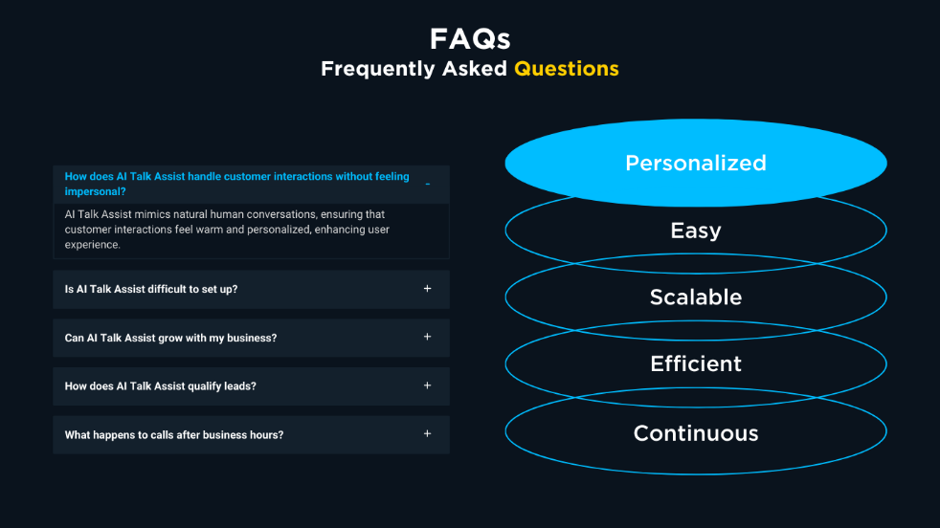

Here is the code

<!-- Calendly inline widget begin -->

<div class="calendly-inline-widget" data-url="https://calendly.com/bkrevoy/60-minute-meeting-for-4ir-consulting?background_color=1a1a1a&text_color=ffffff" style="min-width:320px;height:700px;"></div>

<script type="text/javascript" src="https://assets.calendly.com/assets/external/widget.js" async></script>

<!-- Calendly inline widget end -->

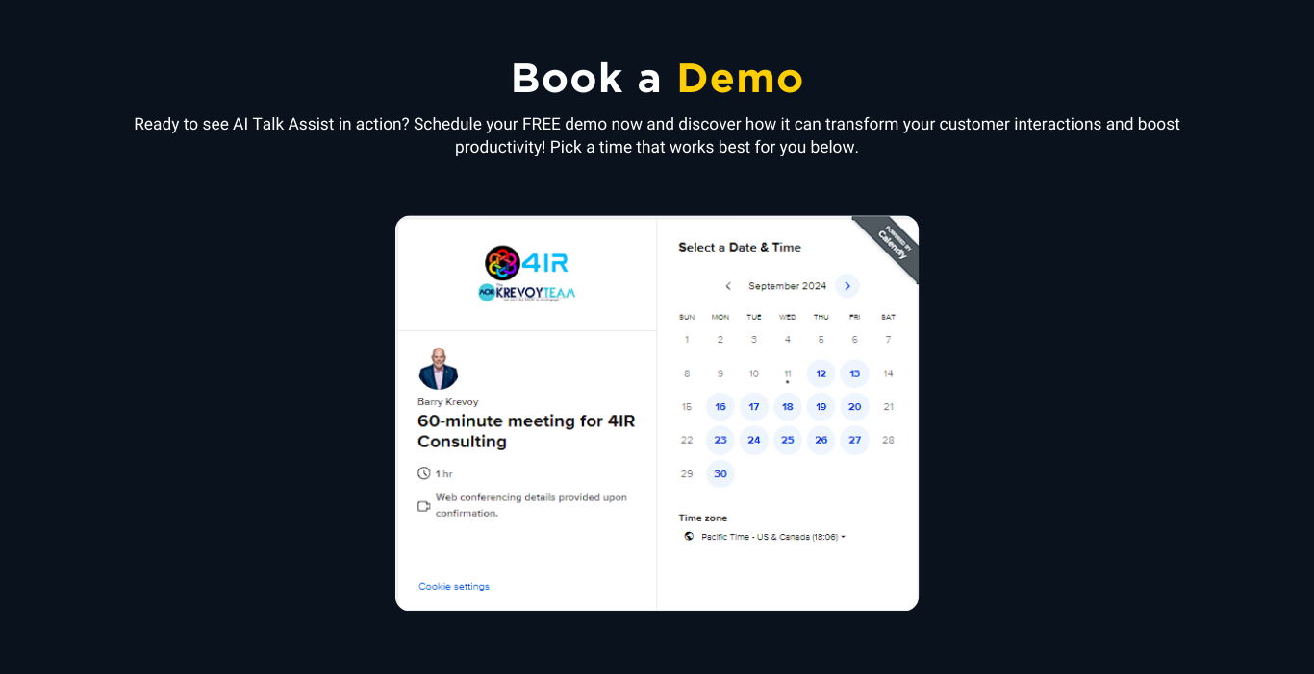

Call to action has the same gif we are using in the home section



On this page we are removing the services list

